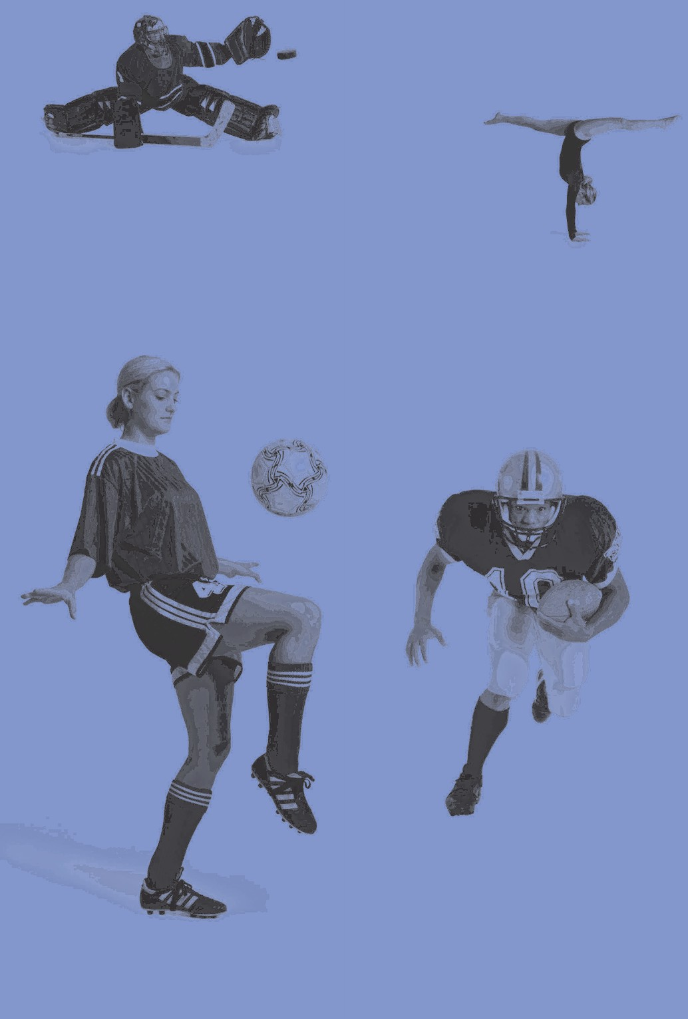





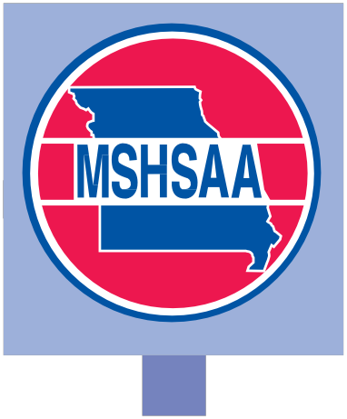

MSHSAA

It’s better to miss one game than the whole season.

For more information and to order additional materials

**free-of-charge**, visit: [**www.cdc.gov/Concussion**.](http://www.cdc.gov/Concussion)

**U.S. DEPARTMENT OF HEALTH AND HUMAN SERVICES**

**CENTERS FOR DISEASE CONTROL AND PREVENTION**

June 2010

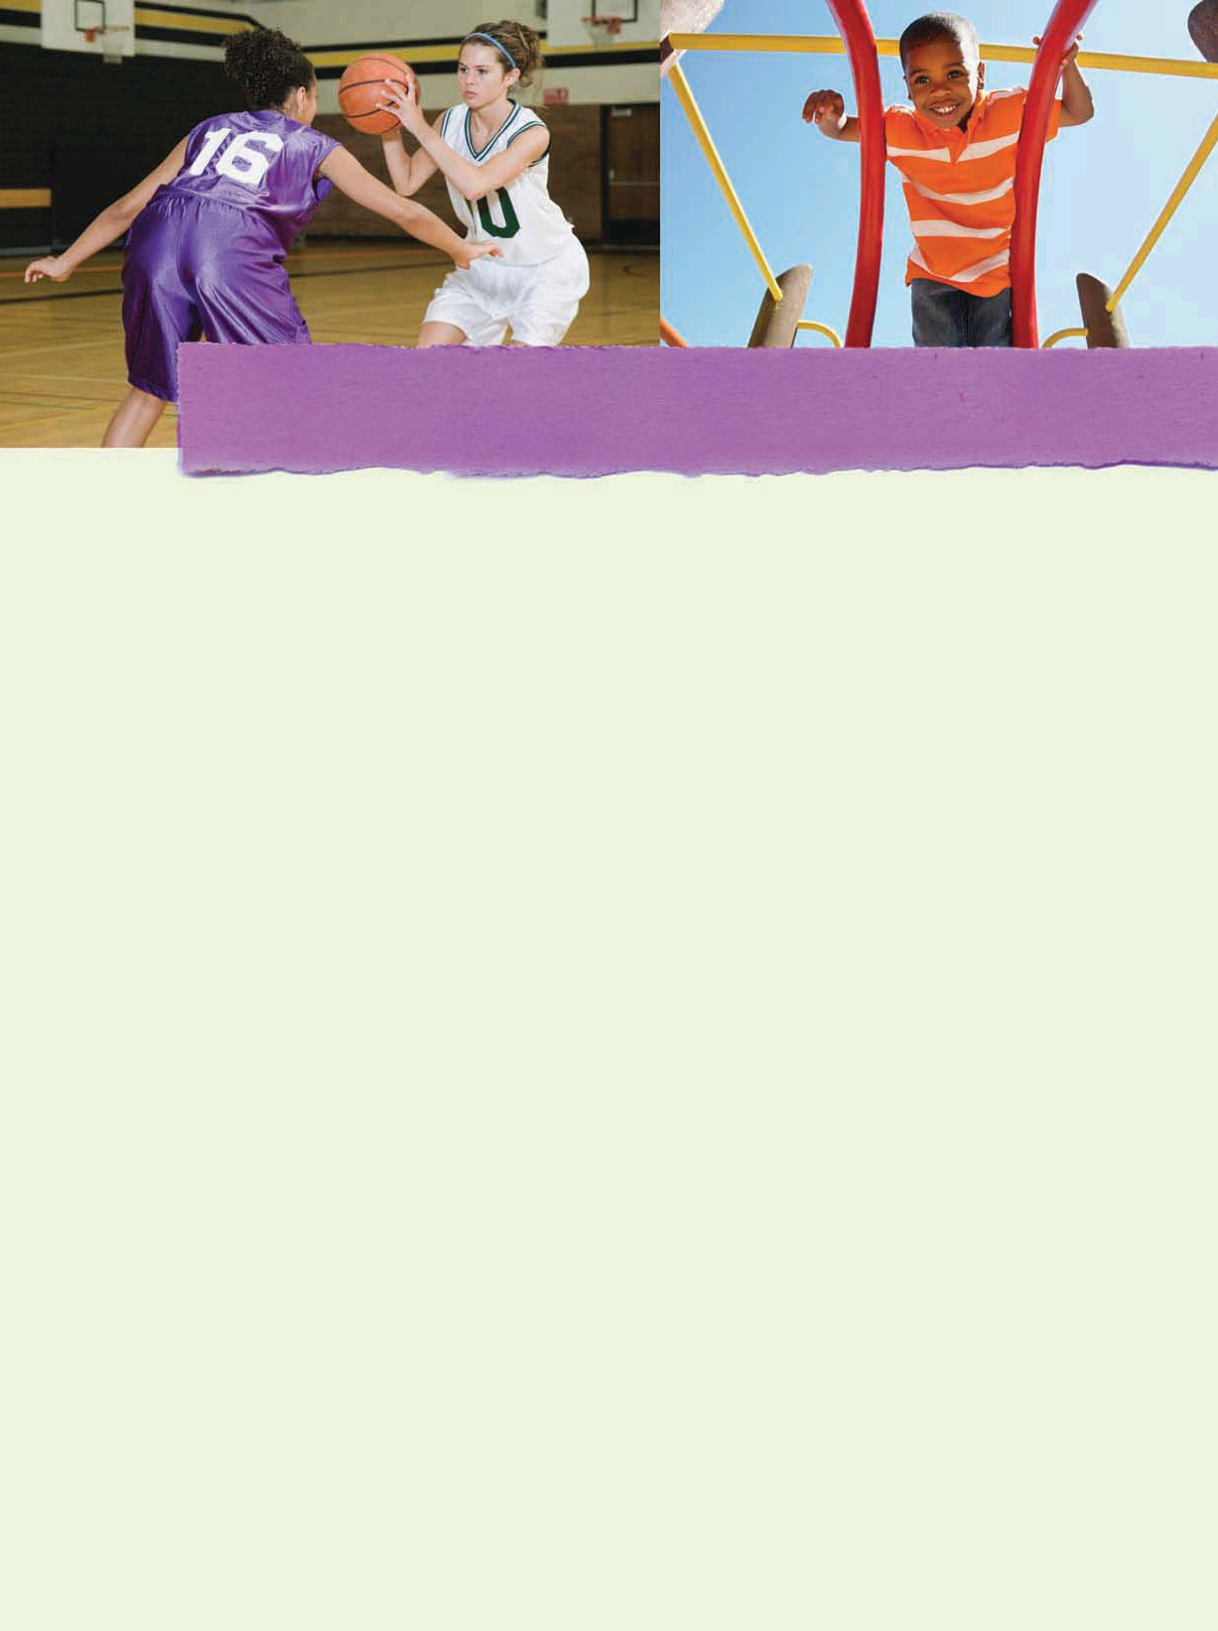





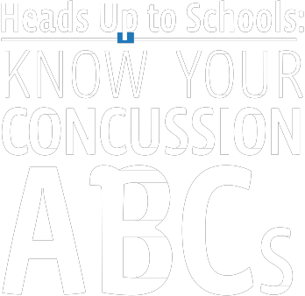

A Fact Sheet for Parents

**A**ssess the situation

**B**e alert for signs and symptoms

**C**ontact a health care professional

What are the signs and symptoms of a concussion?

What is a concussion?

A concussion is a type of brain injury that changes the way the brain normally works. A concussion is caused by a bump, blow, or jolt to the head. Concussions can also occur from a blow to the body that causes the

head and brain to move rapidly back and forth. Even what seems to be a mild bump to the head can be serious.

Concussions can have a more serious effect on a young, developing brain and need to be addressed correctly.

You can’t see a concussion. Signs and symptoms of concussion can show up right after an injury or may not appear or be noticed until hours or days after the injury. It is important to watch for changes in how your child or teen is acting or feeling, if symptoms are getting worse,

or if s/he just “doesn’t feel right.” Most concussions occur without loss of consciousness.

If your child or teen reports one or more of the symptoms of concussion listed below, or if you notice the symptoms yourself, seek medical attention right away. Children and teens are among those at greatest risk for concussion.

SIGNS OBSERVED BY PARENTS OR GUARDIANS

SIGNS AND SYMPTOMS OF A CONCUSSION

SYMPTOMS REPORTED BY YOUR CHILD OR TEEN

• Appears dazed or stunned

• Is confused about events

• Answers questions slowly

• Repeats questions

• Can’t recall events prior to the hit, bump, or fall

• Can’t recall events after the

hit, bump, or fall

• Loses consciousness

(even brieﬂy)

• Shows behavior or personality changes

• Forgets class schedule or

assignments

Thinking/Remembering:

• Difﬁculty thinking clearly

• Difﬁculty concentrating or remembering

• Feeling more slowed down

• Feeling sluggish, hazy, foggy, or groggy

Physical:

• Headache or “pressure” in head

• Nausea or vomiting

• Balance problems or dizziness

• Fatigue or feeling tired

• Blurry or double vision

• Sensitivity to light or noise

• Numbness or tingling

• Does not “feel right”

Emotional:

• Irritable

• Sad

• More emotional than usual

• Nervous

Sleep*:

• Drowsy

• Sleeps less than usual

• Sleeps more than usual

• Has trouble falling asleep

*Only ask about sleep symptoms if the injury occurred on a prior day.

May 2010

To download this fact sheet in Spanish, please visit: [www.cdc.gov/Concussion.](http://www.cdc.gov/Concussion) Para obtener una copia electrónica de esta hoja de información en español, por favor visite: [www.cdc.gov/Concussion.](http://www.cdc.gov/Concussion)

**U.S. Department of Health and Human Services**

**Centers for Disease Control and Prevention**









DANGER SIGNS

Be alert for symptoms that worsen over time. Your child or teen should be seen in an emergency department right away if s/he has:

• One pupil (the black part in the middle of the eye) larger than the other

• Drowsiness or cannot be awakened

• A headache that gets worse and does not go away

• Weakness, numbness, or decreased coordination

• Repeated vomiting or nausea

• Slurred speech

• Convulsions or seizures

• Difﬁculty recognizing people or places

• Increasing confusion, restlessness, or agitation

• Unusual behavior

• Loss of consciousness (even a brief loss of consciousness should be taken seriously)

Children and teens with a concussion should NEVER return to sports or recreation activities on the same day the injury occurred. They should delay returning to their activities until a health

care professional experienced in evaluating for concussion says they are symptom-free and it’s OK to return to play. This means, until permitted, not returning to:

• Physical Education (PE) class,

• Sports practices or games, or

• Physical activity at recess.

What should I do if my child or teen has a concussion?

1. Seek medical attention right away. A health care professional experienced in evaluating for concussion can determine how serious the concussion is and when it is safe for your child or teen to return to normal activities, including physical activity and school (concentration and learning activities).

2. Help them take time to get better. If your child or teen has a concussion, her or his brain needs time to heal. Your child or teen may need to limit activities while s/he is recovering from a concussion. Exercising or activities that involve a lot of concentration, such as studying, working on the computer, or playing video games may cause concussion symptoms (such as headache or tiredness) to reappear or get worse. After a concussion, physical and cognitive activities—such as concentration and learning—should be carefully managed and monitored by a health care professional.

3. Together with your child or teen, learn more about concussions. Talk about the potential long-term effects of concussion and the dangers of returning too soon to normal activities (especially physical activity and learning/concentration). For more information about concussion and free resources, visit: [www.cdc.gov/Concussion.](http://www.cdc.gov/Concussion)

How can I help my child return to school safely after a concussion? Help your child or teen get needed support when

returning to school after a concussion. Talk with your child’s teachers, school nurse, coach, speech- language pathologist, or counselor about your child’s concussion and symptoms. Your child may feel frustrated, sad, and even angry because s/he cannot return to recreation and sports right away, or cannot keep up with schoolwork. Your child may also feel isolated from peers and social networks. Talk often with your child about these issues and offer your support and encouragement. As your child’s symptoms decrease, the extra help or support can be removed gradually. Children and teens who return to school after a concussion

may need to:

• Take rest breaks as needed,

• Spend fewer hours at school,

• Be given more time to take tests or complete assignments,

• Receive help with schoolwork, and/or

• Reduce time spent reading, writing, or on the computer.

,

To learn more about concussion and to order materials FREE-OF-CHARGE

.

go to: [www.cdc.gov/Concussion](http://www.cdc.gov/Concussion) or call 1.800.CDC.INFO

A FACT SHEET FOR ATHLETES

What is a concussion?

A concussion is a brain injury that:

• Is caused by a bump, blow, or jolt to the head or body.

• Can change the way your brain normally works.

• Can occur during practices or games in any sport or recreational activity.

• Can happen even if you haven’t been knocked out.

• Can be serious even if you’ve just been “dinged”

or “had your bell rung.”

All concussions are serious. A concussion can affect your ability to do schoolwork and other activities (such as playing video games, working on a computer, studying, driving, or exercising). Most people with a concussion get better, but it is important to give your brain time to heal.

What are the symptoms of a concussion?

You can’t see a concussion, but you might notice

**one or more** of the symptoms listed below or that you “don’t feel right” soon after, a few days after, or even weeks after the injury.

• Headache or “pressure” in head

• Nausea or vomiting

• Balance problems or dizziness

• Double or blurry vision

• Bothered by light or noise

• Feeling sluggish, hazy, foggy, or groggy

• Difficulty paying attention

• Memory problems

• Confusion

What should I do if I think I have a concussion?

**• Tell your coaches and your parents.** Never ignore a bump or blow to the head even if you feel fine. Also, tell your coach right away if you think you have a concussion or if one of your teammates might have a concussion.

• **Get a medical check-up.** A doctor or other health care professional can tell if you have a concussion and when it is OK to return to play.

• **Give yourself time to get better.** If you have a concussion, your brain needs time to heal. While your brain is still healing, you are much more likely to have another concussion. Repeat concussions can increase the time it takes for you to recover and may cause more damage to your brain. It is important to rest and not return to play until you get the OK from your health care professional that you are symptom-free.

How can I prevent a concussion?

Every sport is different, but there are steps you can take to protect yourself.

• Use the proper sports equipment, including personal protective equipment. In order for equipment to protect you, it must be:

- The right equipment for the game, position, or activity

- Worn correctly and the correct size and fit

- Used every time you play or practice

• Follow your coach’s rules for safety and the rules of the sport.

• Practice good sportsmanship at all times.

**If you think you have a concussion:**

Don’t hide it. Report it. Take time to recover.

It’s better to miss one game than the whole season.

For more information and to order additional materials **free-of-charge**, visit: [**www.cdc.gov/Concussion**.](http://www.cdc.gov/Concussion)

June 2010





**U.S. DEPARTMENT OF HEALTH AND HUMAN SERVICES**

**CENTERS FOR DISEASE CONTROL AND PREVENTION**

**MSHSAA Concussion Return to Play Form**

This form is adapted from the Acute Concussion Evaluation (ACE) care plan on the CDC website ([www.cdc.gov/injurv).](http://www.cdc.gov/injurv)) All medical providers are encouraged to review this site if they have questions regarding the latest information on the evaluation and care of the scholastic athlete following a concussion injury. **Please initial any recommendations that**

**you select below.**

Athlete's Name:

Date of Birth: Date of Injury:

**THIS RETURN TO PLAY IS BASED ON TODAY'S EVALUATION**

Date of Evaluation: Care Plan Completed By:



Return to School On (Date):--------------------------------

**RETURN To SPORTS**

**PLEASE NOTE:** >

1. Athletes should not return to practice or play for at least 24 hours after their head injury has occurred.

2. Athletes should never return to play or practice if they still have ANY symptoms.

3. Athletes: Be sure that your coach and/or athletic trainer are aware of your injury and symptoms, and that they have the contact information for the treating physician.

**The following are the return to sports recommendations at the present time:**

Physical Education: Sports:

**-OR-**

D Do NOT return toPE class at this time.

D May return to PE class at this time.

D Do NOT return to sports practice or competition at this time.

D May gradually return to sports practices under the supervision of the healthcare provider for your school or team.

D May be advanced back to competition after phone conversation with attending physician

(MD/DO/PAC/ ATC/ARNP/Neurophysiologist)

D Must return to physician (MD/DO/PAC/ATC/ARNP/Neurophysiologist) for final clearance to return to competition.

D Cleared for full participation in all activities and restrictions. Return of symptoms should result in re-evaluation by physician (MD/DO/PAC/ATC/ARNP/Neurophysiologist) for

assessment.

**Medical Office Information (Please Print/Stamp):**

Evaluator's Name:

Office Phone: ---------

Evaluator's Signature: Evaluator's Address:

**Return to Play (RTP) Procedures After a Concussion**

1. Return to activity and play is a medical decision. The athlete must meet all of the following criteria in order to

progress to activity:

Asymptomatic at rest and with exertion (including mental exertion in school) AND have written clearance from their primary care provider or concussion specialist (athlete must be cleared for progression to activity by a physician other than an Emergency Room physician, if diagnosed with a concussion).

2. Once the above criteria are met, the athlete will be progressed back to full activity following the stepͲwise process detailed below. (This progression must be closely supervised by a Certified Athletic Trainer. If your school does not have an athletic trainer, then the coach must have a very specific plan to follow as directed by the athlete’s physician).

3. Progression is individualized, and will be determined on a case by case basis. Factors that may affect the rate of progression include: previous history of concussion, duration and type of symptoms, age of the athlete, and sport/activity in which the athlete participates. An athlete with a prior history of concussion, one who has had an extended duration of symptoms, or one who is participating in a collision or contact sport may be progressed more slowly.

4. Stepwise progression as described below:

**Step 1:** Complete cognitive rest. This may include staying home from school or limiting school hours (and studying) for several days. Activities requiring concentration and attention may worsen symptoms and delay recovery.

**Step 2:** Return to school fullͲtime.

**Step 3:** Light exercise. This step cannot begin until the athlete is no longer having concussion symptoms and is cleared by a physician for further activity. At this point the athlete may begin walking or riding an exercise bike. No weightͲlifting.

**Step 4:** Running in the gym or on the field. No helmet or other equipment.

**Step 5:** NonͲcontact training drills in full equipment. WeightͲtraining can begin.

**Step 6:** Full contact practice or training.

**Step 7:** Play in game. Must be cleared by physician before returning to play.

• The athlete should spend 1 to 2 days at each step before advancing to the next. If postͲconcussion symptoms occur at any step, the athlete must stop the activity and the treating physician must be contacted. Depending upon the specific type and severity of the symptoms, the athlete may be told to rest for 24 hours and then resume activity at a level one step below where he or she was at when the symptoms occurred.



"The MSHSAA promotes the value of participation, sportsmanship,

team play and personal excellence to develop citizens who make positive contributions to their community and support the democratic principles of our state and nation."